Migration to S/4 HANA from ECC

**Introduction 2**

Brief History 2

Architecture 2

Flavours 3

**Key technical differences between ECC and S/4 HANA 4**

New process oriented features in S/4 HANA 5

**Benefits of S/4 HANA to the business 6**

**Potential challenges 6**

**Transition to the new SAP world 7**

Migration scenarios 7

New implementation 7

System conversion 7

Landscape transformation 7

Migration strategies 7

Brownfield 7

Greenfield 7

Hybrid 8

CFIN (Central Finance) 8

Preparation 8

Standard tools offered by SAP for the migration 8

S/4 HANA Migration Cockpit 8

Timelines 8

Trial system details 9

**References 10**

SAP HANA 10

Fiori 10

Row and columnar storage of data 11

Public Cloud 13

# Introduction

SAP S/4 HANA is an ERP (Enterprise Resource Planning) software package. The term **S/4 HANA** is the short form used for SAP Business Suite 4 HANA. It is the latest offering of SAP. The business suite runs on SAP HANA as the database and offers a simplified user interface.

Know more about SAP HANA.

## Brief History

After three generations of ERP systems - R1, R2 and R3 (R stands for Real Time), S/4 HANA is the fourth generation ERP system.

R1 and R2 are mainly based on Mainframes. Whereas, R3 is based on the client-server-application architecture which is also called 3-tier architecture.

After these, SAP S/4 HANA, which is the fourth generation business suite, was introduced by SAP in November 2015.

## Architecture

S/4 HANA is based on the ABAP platform like its ERP (Enterprise Resource Planning) predecessors. It is built with three important blocks:

1. HANA platform or HANA database.
2. S/4 HANA - The business suite which takes advantage of the HANA database.
3. Fiori - the new simplified UI (User Interface) focussed on app style development.

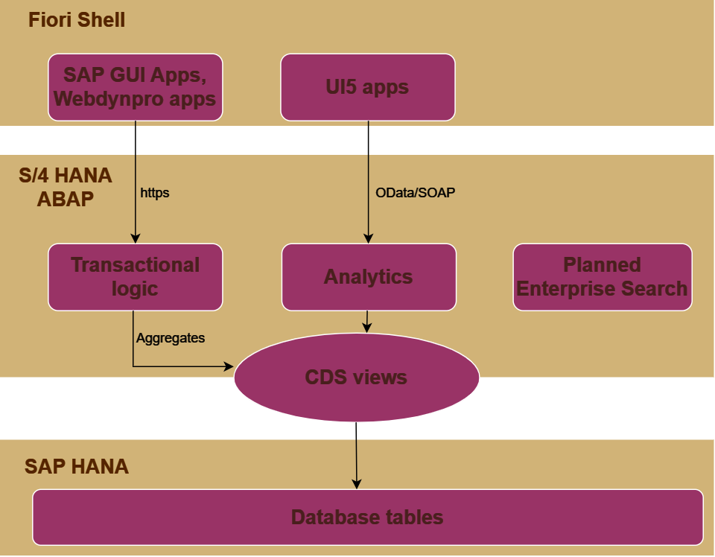

Figure 1

## Flavours

SAP S/4 HANA is available in two different flavours:

* Cloud
* On Premise

The highlights and differences of each flavour is detailed in the table below. You can choose your preferred flavour based on your organisation’s business needs.

| **Factor** | **Cloud** | **On Premise** |
| --- | --- | --- |
| Installation | On SAP’s server | On customer’s server |
| Licensing/Payment | Monthly subscription model | Traditional licensing with a one time fee |
| Suitability | This adds value to the customers who are looking for a light and simple ERP system to scale while growing | This offers lots of value to the customers who are looking for a highly customisable system |
| Upgrades and maintenance | Upgraded and maintained by SAP once in a quarter. | Yearly upgrades will be provided by SAP. It's up to the customer to upgrade the system.  Maintenance to be done by the customer. |
| Customizability | Very less room for customization.  Industry standards are already embedded.  Customers don’t have IMG (Implementation Guide) and backend access. | Highly customizable.  Customers have IMG (Implementation Guide) and backend access. |
| Deployment timelines | Takes shorter time as it involves only the delivery of the template solution | Needs longer time for installation as it involves physical server installation and customization |
| Initial investment | Lower upfront cost as no hardware needs to be purchased | High initial investment as it involves purchasing of the physical servers. |
| Scalability | Less scalable | Scalable to all offered components |
| Infrastructure | SAP’s responsibility | Customer’s responsibility |

# Key technical differences between ECC and S/4 HANA

| **ECC** | **S/4 HANA** |
| --- | --- |
| Capable of running on third party databases like Oracle, IBM DB2 etc. | Can run only on SAP HANA. |
| OLAP (Online Analytical Processing) and OLTP (Online Transaction Processing) functions are set up in different systems. | OLAP and OLTP functions are set up in the same system. |

## 

## New process oriented features in S/4 HANA

1. **Universal Journal** - ACDOCA introduced which is the single source of truth. This eliminates many aggregate and index tables. This leads to lesser data footprint as data insert happens in a single table rather than underlying multiple tables.
2. **Inventory Management** - MATDOC - a new table replacing many tables like MKPF and MSEG for storage of material documents.
3. **Business Partners are mandatory** in S/4 HANA. All customers and vendors must be migrated and integrated as business partners in S/4 HANA.
4. **Material number extension** (Optional) - Material number which is only 18 characters long in ECC, can extend up to 40 characters in S/4 HANA.

Note: It is important to evaluate the impact of switching on this feature in integration scenarios and interfaces before doing so.

1. **Credit Management** - The new module FSCM-CR replaces the credit management module in ECC (FI-AR-CR). The new module offers interfacing with external credit rating agencies.
2. **SD Pricing** - New tables like PRCD_ELEMENTS with extended fields replace existing tables like KONV.
3. **Real time MRP (Material Requirement Planning)** - Batch job runs are used in ECC to perform MRP. In S/4 HANA, this can be done real time. MRP with subcontracting is also simplified in S/4 HANA.
4. **Global trade services** - Foreign trade functionalities supported in ECC are now replaced with Global trade services in S/4 HANA.
5. **Material ledger activation** - It is optional in ECC. In S/4 HANA, it is mandatory to activate material ledger. ECC customers don’t activate material ledger for reasons around system performance and effort. But with S/4 HANA, the process is much smoother due to simplified data models and universal journal.
6. **Revenue accounting and reporting** - Revenue accounting and reporting module replaces ECC’s SD (Sales and Distribution) revenue accounting.

## 

# Benefits of S/4 HANA to the business

1. Background jobs and aggregate tables are not used which simplifies driving the business processes in real time.
2. The performance planning, execution, report generation and analytics become improvised due to live business data available.
3. S/4 HANA system landscape is much simplified compared to ECC landscape making it easier for the business users to operate the system.
4. In many business processes, a single table with extended fields replaces multiple underlying tables. This leads to a lesser data footprint in the system. The system performance is higher.
5. Reduced cost for business - Multiple business processes are automated in S/4 HANA. This leaves the users with more time for productive tasks that need human intelligence. With a lesser number of users required to operate the system, the organisation can save money on manpower.

# Potential challenges

1. **Functionality** - As S/4 HANA is very vast covering lots of modules, sub-modules and features, it is challenging to identify which of them exactly suits the organisation’s business requirements.
2. **High implementation cost** - Each module of ERP calls for purchasing a separate licence. In addition, hiring consultants for the implementation and training users to use the new system shoot up the budget of the implementation project.
3. **Training users** - S/4 HANA is a complex software. It is mostly designed for large organisations only. Smaller organisations find it difficult to use all offered features. Very Detailed and precise documentation is required to onboard users to the new system.
4. **Planning and strategy** - A detailed project plan and business strategy needs to be done well in advance to the implementation project. Minimum of one year preparation is required in most of the organisations.
5. **Availability of support** - Due to high complexity of the system and the software being relatively new, support consultants are not easily available in the market for hiring.

# 

# Transition to the new SAP world

## Migration scenarios

### New implementation

Customers who transition from an old legacy system to S/4 HANA come under this scenario. Initial data load must be performed. Master and transaction data must be loaded from the legacy system to S/4 HANA. SAP delivered standard content and migration tools will be helpful.

### System conversion

Customers who are on an SAP system already but would like to get on to S/4 HANA come under this scenario. SAP delivered tools such as Software Update Manager (SUM) and Database Migration Option (DMO) will be of help to such customers.

### Landscape transformation

Customers who wish to consolidate a complex ECC or existing ERP landscape into a simple S/4 HANA system landscape lie in this scenario. This involves preparation of the target master S/4 HANA system and transfer of data using the tool SAP Landscape Transformation (SLT). SLT can be used for single time data transfer only, and not for continuous data transfer.

## Migration strategies

### Brownfield

This strategy reuses existing processes with minimal business disruption.

This strategy suits best when the customer wants to migrate to S/4 HANA selecting only a few components.

Though it requires less time to complete the implementation, it has limited scope for process reengineering, simplification and optimization. It is not very compatible with future facing technology. Higher costs are incurred to adapt to standard processes in future course,

### Greenfield

This calls for a fresh SAP S/4 HANA box. The business processes are completely re-engineered with required optimization, simplification and re-definition.

This strategy allows the customer to bring in all the advanced features delivered by SAP maintaining the best of industry standards. It provides an opportunity to the customer to close old process gaps and implement lessons learnt from the past. However, this calls for a substantial change management effort resulting in high implementation cost and a long project timeline.

### Hybrid

This strategy combines the best of both greenfield and brownfield. As a baseline, it makes use of existing ERP processes on the top of which simplification, optimization and innovations derived from S/4 HANA are layered.

### CFIN (Central Finance)

An S/4 HANA box is centrally introduced into the system landscape. This pulls data from various SAP systems on a real time basis. Later, it consolidates the data which can be used for reporting purposes. This strategy brings the reporting capabilities of S/4 HANA to an existing ECC landscape.

## Preparation

Preparation is key to an SAP S/4 HANA implementation project. A minimum of 6-12 months of ground work in all of the following areas has to be done before the project begins.

* Cleansing master and transaction data in the existing system for it to fit in the S/4 HANA box.
* Studying the existing processes and configurations for an in-depth understanding of as-is state of the system.
* Documenting the existing issues in the system.
* Documenting the custom developments in the system.
* Ensuring the right resources are available for the project.
* Ensuring issues in the current system are included in the scope consideration of the project as part of the business case.

## Standard tools offered by SAP for the migration

### S/4 HANA Migration Cockpit

This tool is helpful in migrating data and applications to the S/4 HANA platform. This can be used to migrate data from any SAP or non-SAP source system. It offers a simplified GUI, pre-built migration scenarios for data migration, flexibility in customising the tool to meet customer’s specific needs. The cloud offering comes with a built-in migration cockpit. It is available within the fiori application - Manage Your Solution. Back to migration scenarios.

## Timelines

SAP will continue to support ECC systems till 2027. Post that, only S/4 HANA will be supported by SAP.

## Trial system details

SAP supports new customers in the S/4 HANA world via two offerings:

* 14 day guided free trial of SAP S/4 HANA public cloud system.
* 90 day free trial of SAP HANA system.

Conclusion

Migration to S/4 HANA is an inescapable step all customers of SAP have to take as support to ECC systems will be discontinued in the long run. Though suitability of S/4 HANA to various customers is subjective, SAP has managed to fill this gap up to the maximum possible extent by offering the solution in various flavours as discussed in this article. Customers must carefully analyse the situation based on various factors highlighted in this article to be able to come to a fruitful solution to their business needs.

# 

# References

## SAP HANA

HANA stands for **H**igh **P**erformance **AN**alytic **A**ppliance. This database was invented by Haso Plattner (Co-founder of SAP) in the mid 2000s.

This database stands on two architecture principles:

1. **In memory computation** - SAP HANA contains terabytes of memory. All data is available on the main memory which avoids the performance penalty caused by disk I/O (Input/Output) operations. Auxiliary memory is not used for day to day business operations. However, it is used for backup and recovery.
2. **Row and columnar storage of data** - Traditional database systems use row storage which leads to a lot of data duplication. HANA has the option to store data in columnar or row format. In the case of columnar data storage, indexing and data compression techniques are used to store duplicate values to enhance performance. .

Row and columnar data storage in detail.

Go back to Introduction.

## Fiori

Fiori is SAP’s new approach to UI design. It allows developers to build apps for business processes within SAP. The apps are adaptable between mobile, tablet and desktop.

Fiori is highly role based. All users are assigned appropriate roles based on their activities in the system. Only the apps and screenfields that cater to the role of the user are displayed. This avoids redundancy and adds simplicity in terms of what a user sees when logged into the system.

For example, A user who is assigned a “Purchaser” role will be able to see apps and fields only pertaining to purchasing functions (apps like Manage Purchase Order, Create Purchase Order, Purchase Order Workflow etc.). Other apps are not displayed to this user.

Back to Architecture of S/4 HANA.

## 

## Row and columnar storage of data

Let us understand this technique with an example.

Consider a table containing the data of the Indian states.

| **State** | **Population (in Crores)** | **Area (In square Km.)** | **Capital city** | **Crop** |
| --- | --- | --- | --- | --- |
| Karnataka | 6.5 | 191791 | Bengaluru | Rice |
| Maharashtra | 13.2 | 308000 | Mumbai | Fruits |
| Tamil Nadu | 7.7 | 130060 | Chennai | Rice |
| Kerala | 3.6 | 38863 | Thiruvananthapuram | Rice |
| Andhra Pradesh | 9.5 | 160205 | Amaravati | Rice |

Row data storage:

| Row1 | Karnataka |
| --- | --- |
| 6.5 |
| 191791 |
| Bengaluru |
| Rice |
| Row2 | Maharashtra |
| 13.2 |
| 308000 |
| Mumbai |
| Fruits |
| Row3 | Tamil Nadu |
| 7.7 |
| 130060 |
| Chennai |
| Rice |
| Row4 | Kerala |
| 3.6 |
| 38863 |
| Thiruvananthapuram |
| Rice |
| Row5 | Andhra Pradesh |
| 9.5 |
| 160205 |
| Amaravati |
| Rice |

Columnar data storage:

| State | Karnataka |
| --- | --- |
| Maharashtra |
| Tamil Nadu |
| Kerala |
| Andhra Pradesh |
| Population (In crores) | 6.5 |
| 13.2 |
| 7.7 |
| 3.6 |
| 9.5 |
| Area (In Sq. Km.) | 191791 |
| 308000 |
| 130060 |
| 38863 |
| 160205 |
| Capital city | Bengaluru |
| Mumbai |
| Chennai |
| Thiruvananthapuram |
| Amaravati |
| Crops grown | Rice |
| Fruits |
| Rice |
| Rice |
| Rice |

Consider a query: Get the states of India that grow Rice as the major crop.

In a row store table, the search will have to be performed on every row to know if the state grows rice. Whereas, in the column store table, a range of rows having rice as the major crop can be used to narrow the search. This enhances performance dramatically.

Go back to SAP HANA.

## Public Cloud

Public cloud is an infrastructure in which system services are offered over a network that is open for public usage. In case of SAP, SAP S/4 HANA public cloud offering is completely maintained by SAP. It is a cost effective solution for consuming software. A completely pre configured SAP solution is delivered to the customer. This is most suitable for small to medium scale organisations whose priorities are cost reduction and standardisation. System is not customisable. Access to the backend is not provided. Go back to trial system details.